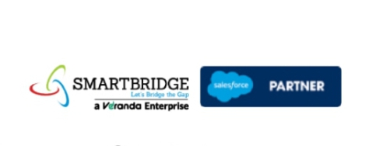

**WORKFORCE ADMINISTRATION SOLUTION**

**Team Members: Naan Mudhalvan ID:**

SUDESHWARI V 10197EBDAC54B1880304EDC4697C1D4F

RAJALAKSHMY D B0DFE3CD579F9AA98CC4B892D8439FE6

THIREKHA V 5F4E81D3BD907AD9E91461D27DEC6EF6

VANAJAKUMARI M 77F2B0B4160D0CFA1064AC7B905CDC6A

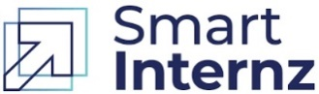

**Project Overview:**

The Workforce Administration Solution aims to streamline and optimize the management of human resources across an organization. This includes automating key HR processes, enhancing employee lifecycle management, and improving compliance, reporting, and decision-making through advanced tools and analytics.

**Objectives:**

Design and implement a comprehensive workforce administration solution to streamline and automate HR-related processes, enhance employee experience, and improve organizational efficiency.

**Salesforce Key Features and Concepts Utilized.**

* **Custom Objects & Fields:**

Custom objects are data structures created to store information that doesn’t fit into standard objects provided by the system. For workforce administration, like employee object, Asset object and Asset Service object.

* **Page Layouts & Lightning Apps:**

When implementing page layouts and Lightning apps in a workforce administration solution, particularly in platforms like Salesforce, these features enhance user experience, streamline workflows, and ensure efficient data management.

* **Apex Triggers & Classes:**

Apex Triggers and classes in Salesforce can play a significant role in automating and enhancing workforce administration processes.

* **Setting OWD :**

Organization-Wide Defaults (OWD) in a workforce administration solution determine the baseline level of access users have to records they don’t explicitly own. In platforms like Salesforce, OWD settings are a key component of security and access control for objects such as Employee Records, Leave Requests, or Shift Schedules.



* **Reports & Dashboards:**

Reports and Dashboards in a workforce administration solution are essential for monitoring workforce metrics, analyzing trends, and making data-driven decisions.

* **Approval Process:**

An Approval Process in a workforce administration solution automates record approval workflows, ensuring accountability, compliance, and efficiency. Platforms like Salesforce allow for creating robust approval processes to handle common workforce tasks, such as leave requests, shift changes, or performance reviews.

**Detailed Steps to Solution Design for Workforce Administration solution in salesforce:**

* **Employee object:**

An employee custom object is to keep track the employee activities and their individuals and as well as team progress.

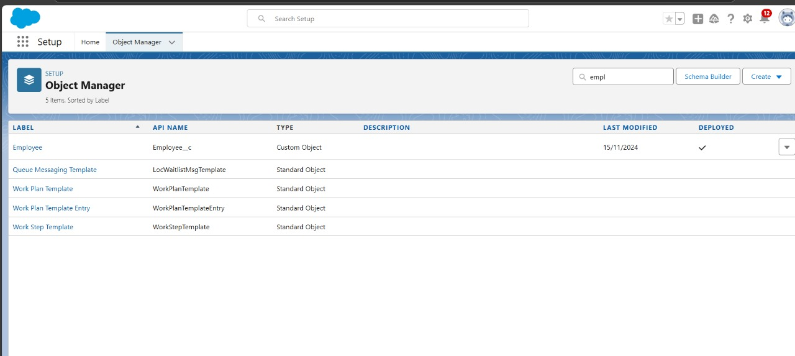



* **Asset Object & Asset Service object:**

Use “Text” as a data type and label Record Name as “Project Task Name”.

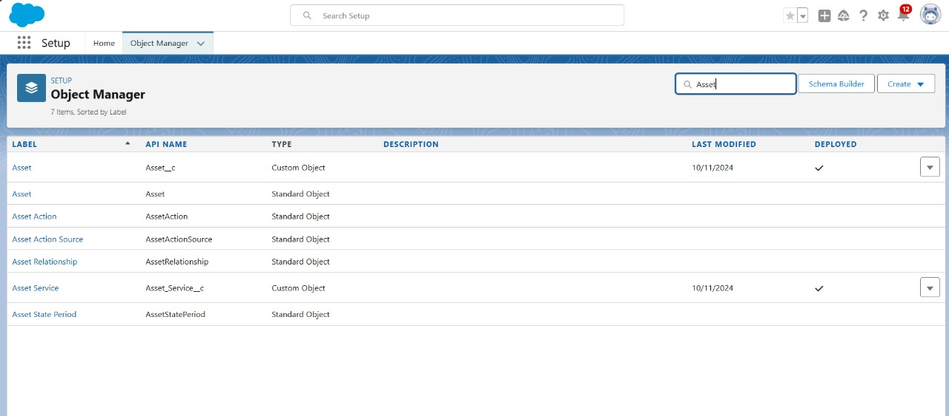

* **Creating Custom Tab:**

A **customer tab** is a user-defined tab that displays custom objects, employee, Asset, Asset service within the Salesforce interface.

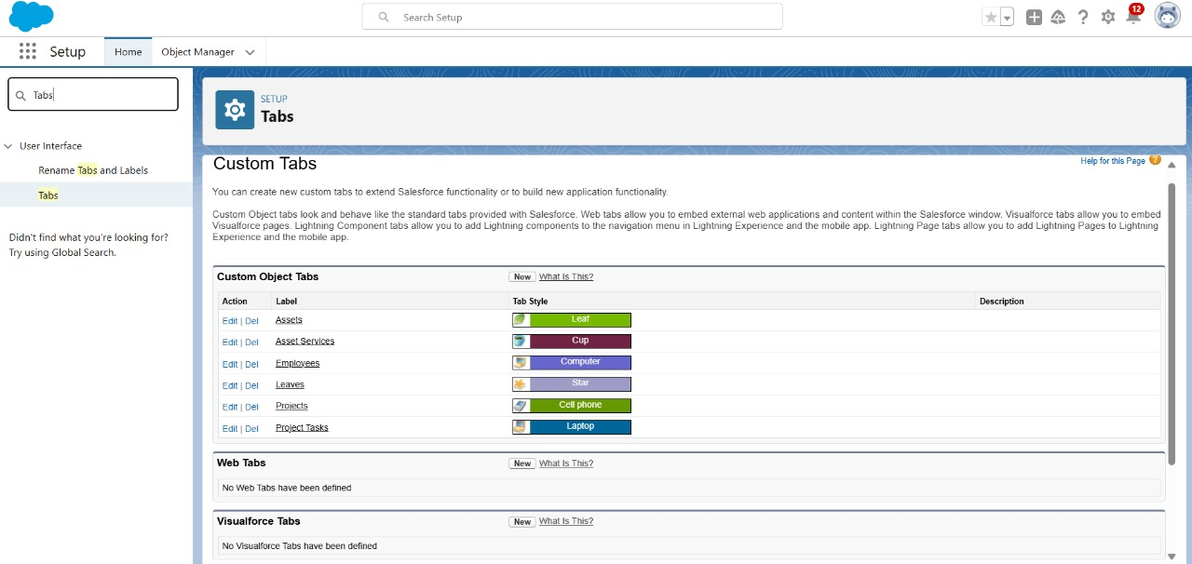



* **Lightning App:**

* Create a Custom Lightning App that integrates the following components.
* Employee records.
* Asset record.
* Asset service

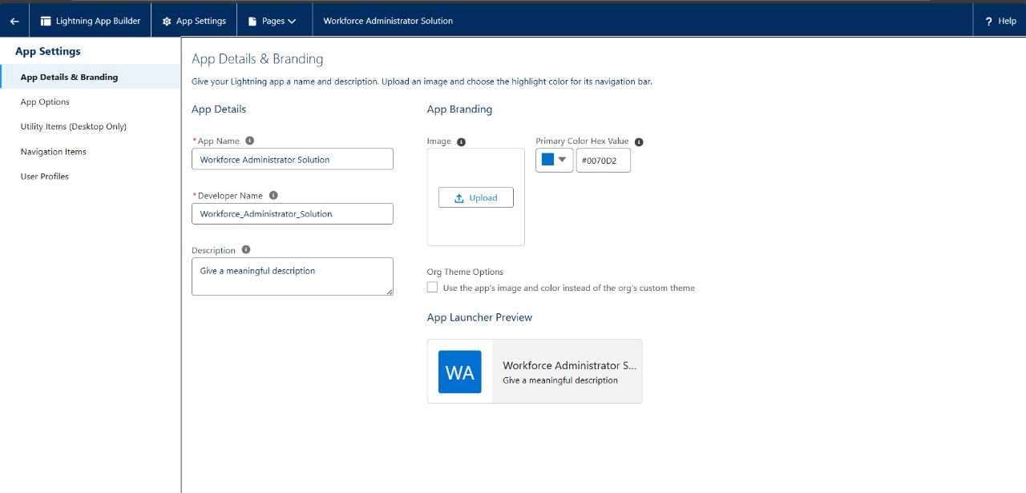

* **Creating Fields & Relationships:**

Fields represent the data stored in the columns of a relational database. It can hold any valuable information that you require for a specific object. Hence overall searching , deletion, and editing of the records become simpler and quiker.

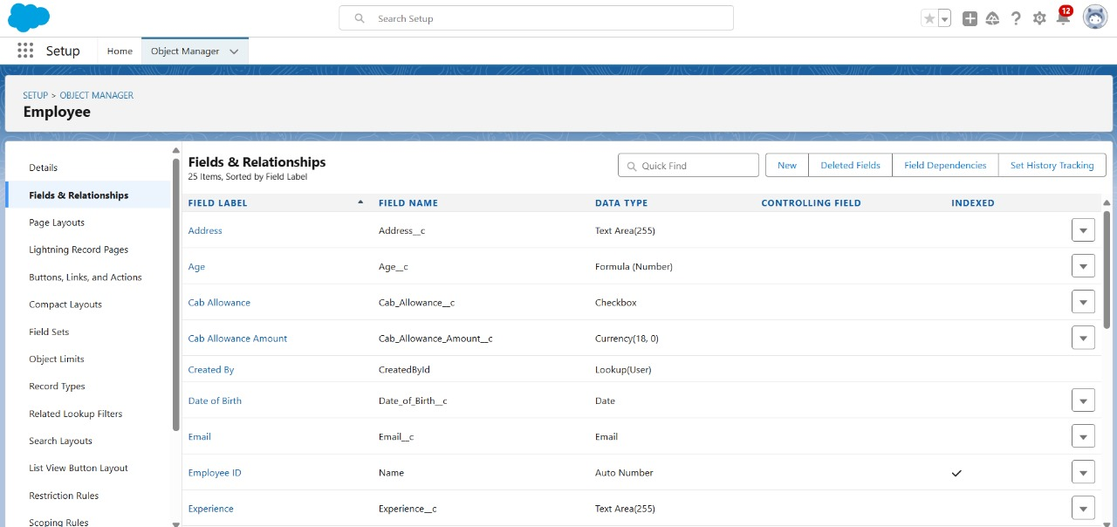

 **S** 

* **Creating OWD Setting:**

To ensue data privacy and compliance with regulations, need to restrict access to sensitive customer information using OWD.

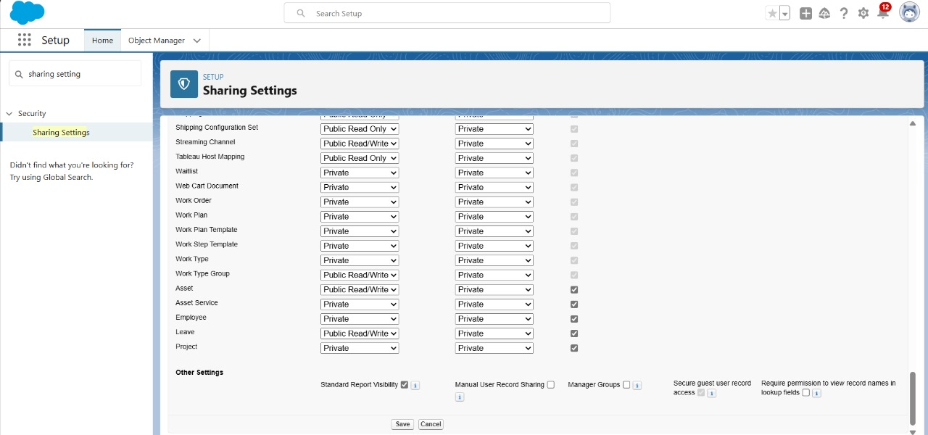

Fields represent Fields represent

* **Importing Data Using Data Wizard:**

Upload data from external sources and combine it with data you collect via Analytics . The data import Wizard is a Tool makes it easy to import data forn many standard salesforce objects including accounts, contacts, leads, solutions, campaign members, and person accounts.

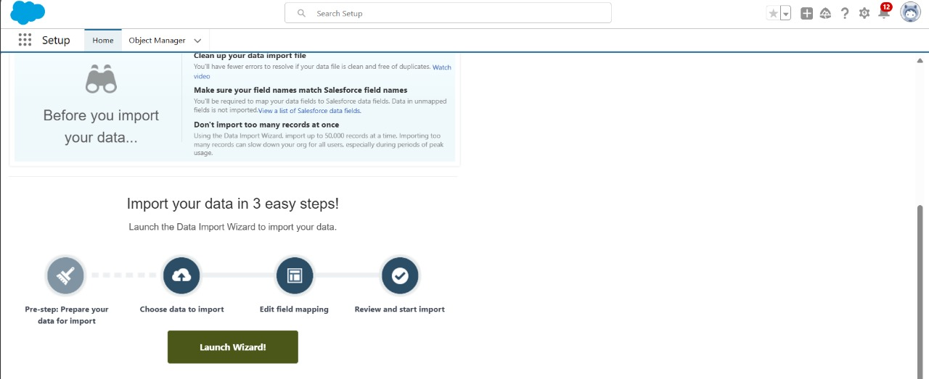



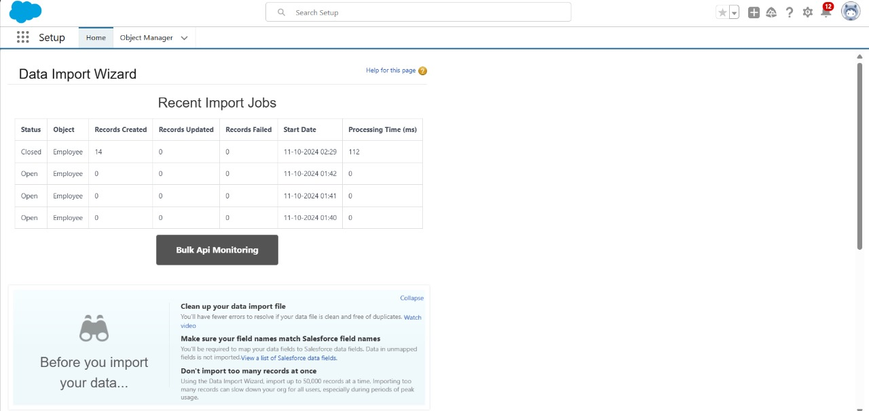

* **Creating HR Role:**

A Role defines a users visibility access at the record level. Roles may be used to specify the types of access that people in your salesforce organization can have ton data. By expanding all to add the role under whom the role works the label name as HR, assigning role responsibilities, custom object employee.

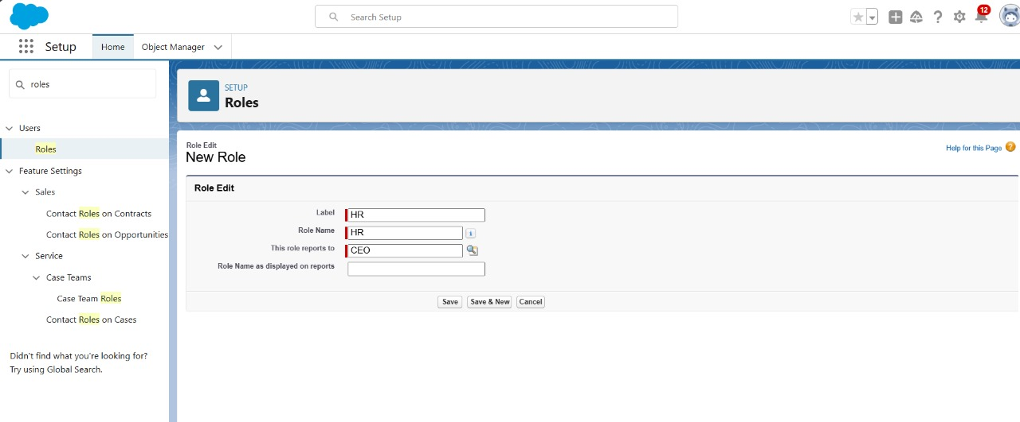



* **Creating User:**

A user is anyone who logs in to Salesforce. Users are employees in a company such as sales reps, managers, and IT specialists, who need access to the company records.

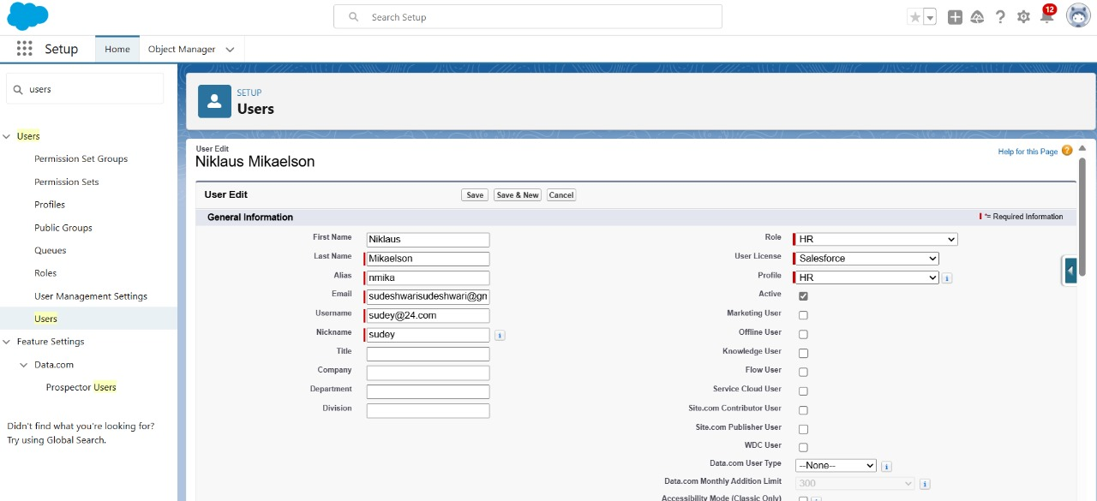

* **Page Layouts:**

Page Layout in salesforce allows us to customize the design and organize detail and edit pages of records in Salesforce. Page layouts can be used to control the appearance of fields, related lists, and custom links on standard and custom object’s detail and edit pages.

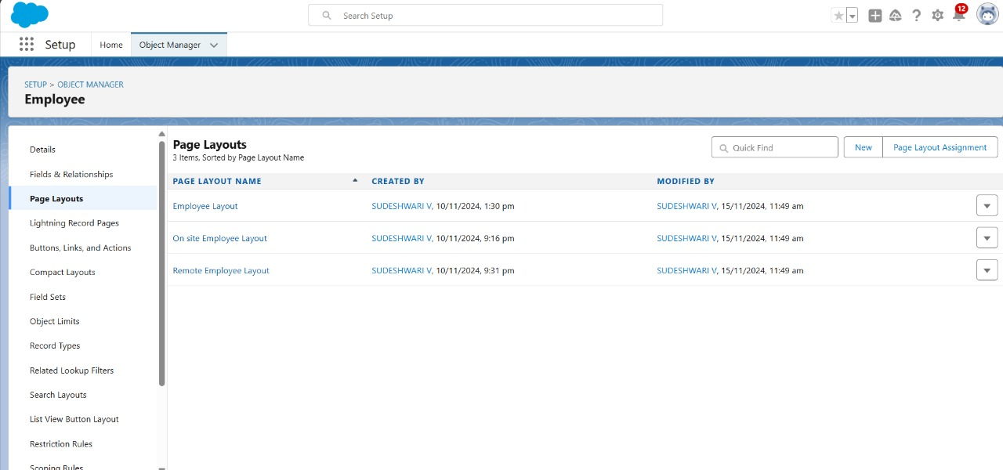



* **Creating Chatter Groups:**

Salesforce Chatter Groups are collaborative spaces within the Salesforce platform that enable teams to communicate, share information, and collaborate on projects. They provide a centralized hub for discussions, file sharing, and updates, allowing users to stay connected, streamline workflows, and enhance productivity.

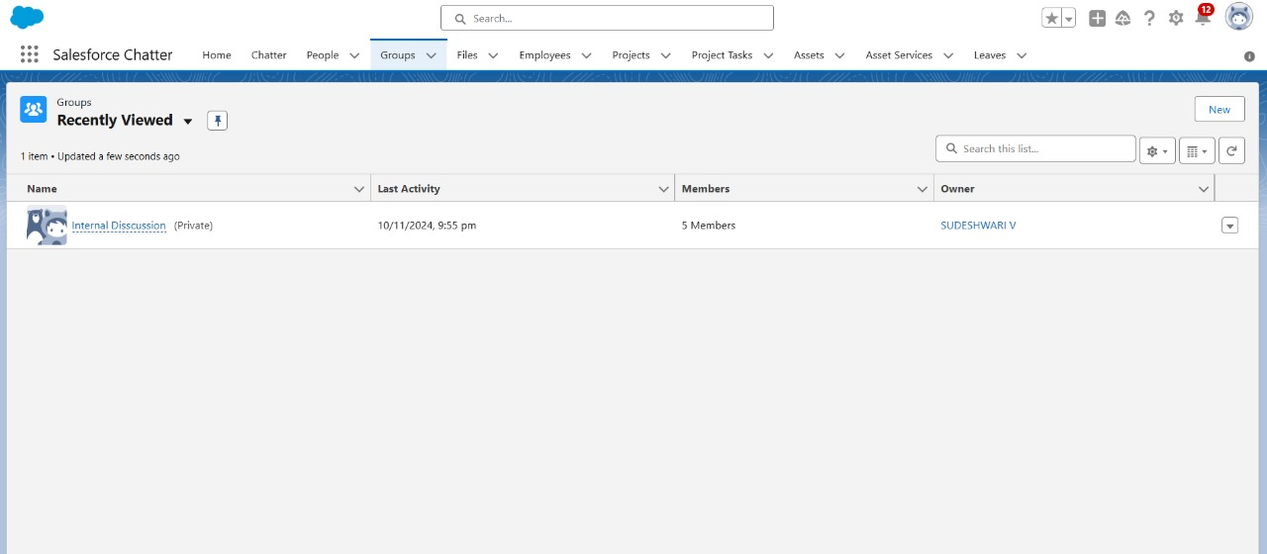

* **Creating On Site Employee Record:**

Record Types are a way of grouping many records of one type for that object. These can be applied to any standard or custom object, and allow you to have a different page layout, fields, required fields, and picklist values. Record types allow administrators to create a different page layout with custom picklist fields and values for the same business process and various business processes.

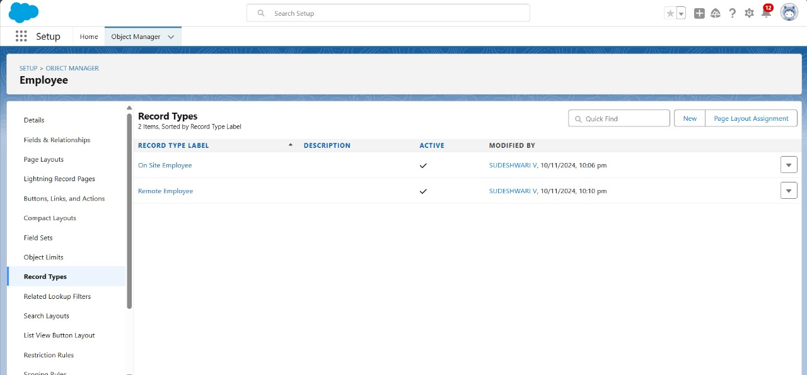



* **Permission Sets:**

A permission set is a collection of settings and permissions that give users access to various tools and functions. Permission sets extend users' functional access without changing their profiles. Users can have only one profile but, depending on the Salesforce edition, they can have multiple permission sets**.**

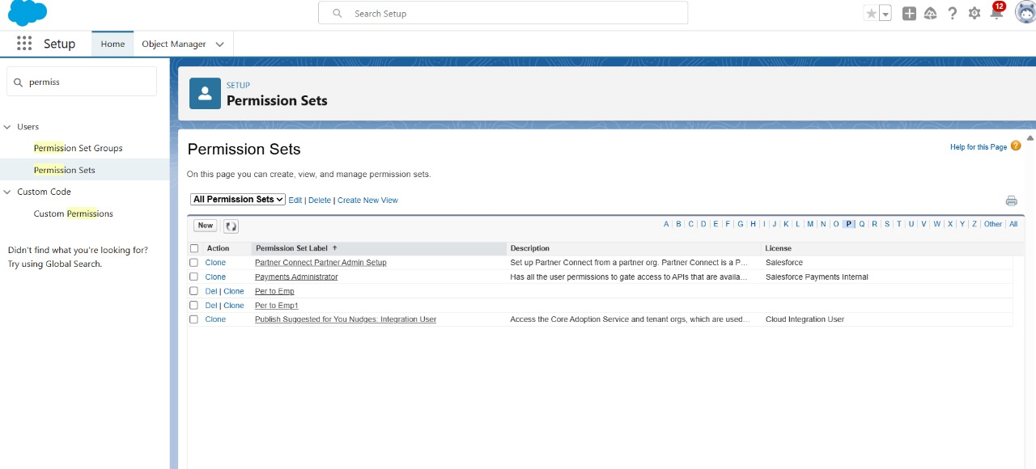

* Reports:

* **Report:**

Reports give you access to your Salesforce data. You can examine your Salesforce data in almost infinite combinations, display it in easy-to-understand formats, and share the resulting insights with others. Before building, reading, and sharing reports, review these reporting basics.

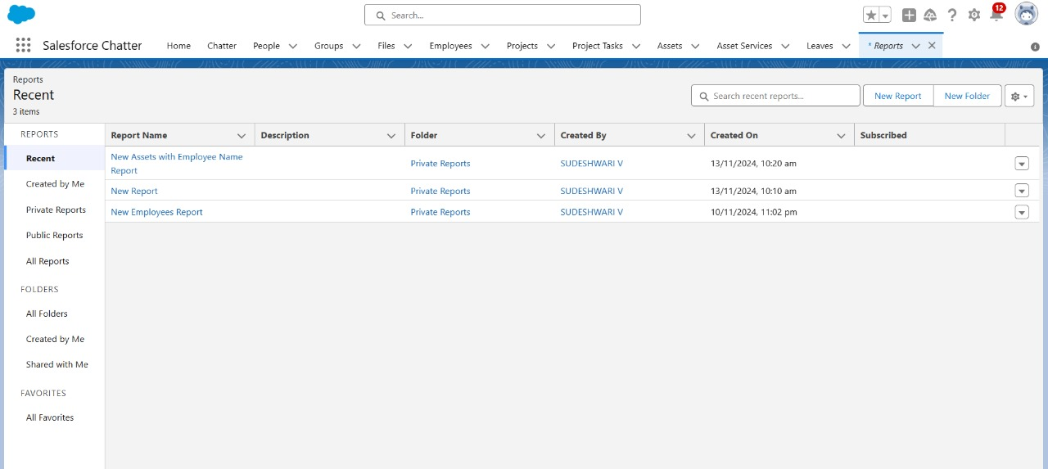



* **Dashboard:**

Dashboards help you visually understand changing business

conditions so you can make decisions based on the real-time data

you’ve gathered with reports. Use dashboards to help users identify

trends, sort out quantities, and measure the impact of their activities.

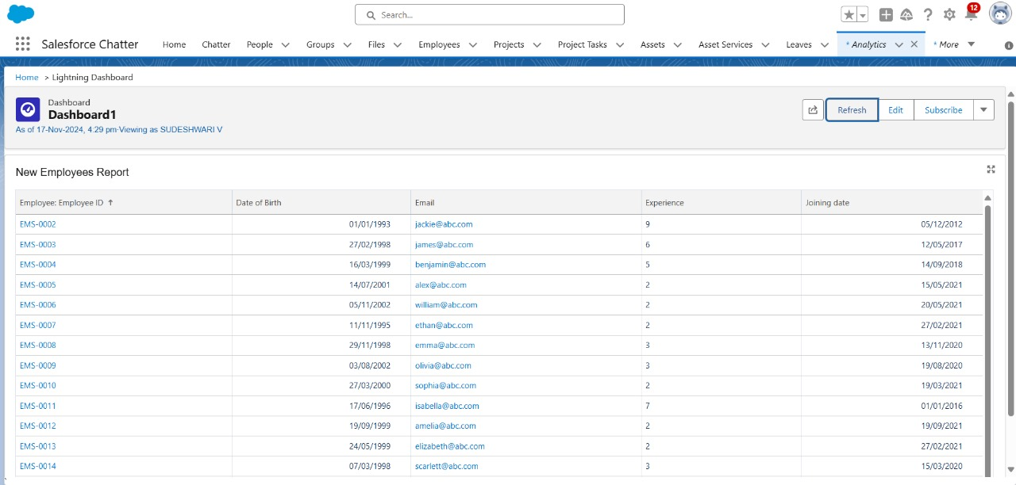

* **Approval Process:**

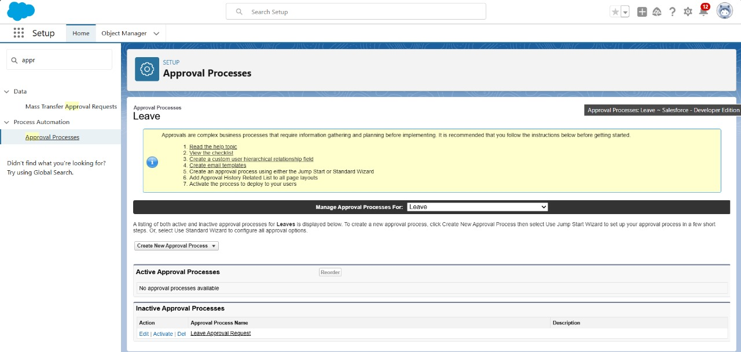A set of steps designed to review, validate, and authorize tasks or transactions related to workforce management. This process ensures that actions like employee onboarding, promotions, leave requests, and payroll changes comply with organizational policies and are properly documented.



* **Apex Trigger:**

To automate processess related to employee rcords, leave management,

Work hours tracking, or any other HR-Related tasks managed in salesforce.

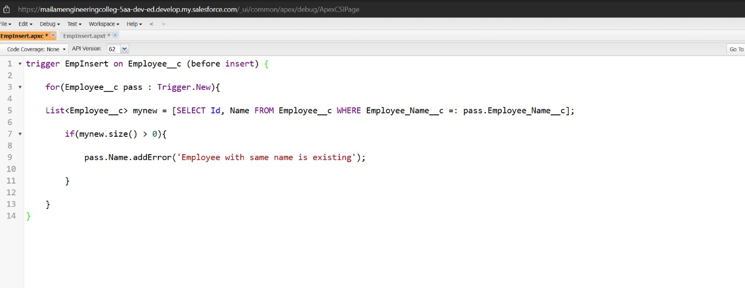

**Testing and Validation for the Workforce Administration solution Project:**

Testing and validation in workforce administration are essential to ensure that the strategies, systems, and policies implemented are effective, efficient, and meet organizational objectives. Testing involves evaluating the performance and functionality of workforce management tools, such as scheduling software, payroll systems, and time-tracking mechanisms. This ensures that the system can handle various scenarios, such as peak work hours, overtime calculations, and employee availability. Validation goes beyond functional testing to assess whether these systems meet legal and compliance standards, organizational needs, and employee expectations. This includes checking whether the payroll complies with labor laws, ensuring equitable scheduling practices, and verifying that employee data privacy is protected.



Effective testing and validation in workforce administration also focus on the alignment between workforce strategies and organizational goals. For example, validating the effectiveness of training programs can determine if employees have the necessary skills to perform their roles, enhancing overall productivity. Testing the recruitment process ensures that hiring procedures attract the best candidates while aligning with diversity and inclusion initiatives. Furthermore, testing the communication systems within workforce management ensures that employees receive accurate and timely information, fostering transparency and trust.

Moreover, these processes help identify potential risks, such as errors in payroll, under-staffing, or misalignment between demand and staffing levels. Regular testing and validation allow for timely corrective actions and adjustments to workforce management policies and systems, optimizing performance and enhancing employee satisfaction. By maintaining rigorous testing and validation processes, organizations can adapt to changing workforce dynamics and legal requirements, ensuring long-term success and operational efficiency.

**Key Scenarios Addressed by Salesforce in the Implementation Project:**

**1. Centralized Employee Data Management**

**Scenario:** Disparate systems for employee data make it hard to maintain consistency and access real-time information.

**Salesforce Solution:**

* Create a unified Employee Profile object to store all employee-related data, including personal details, roles, job history, and performance metrics.
* Integrate with HR systems like Workday or SAP SuccessFactors for seamless data syncing.
* Use automation to update data across connected systems in real-time.



**2. Streamlined Recruitment and Onboarding**

**Scenario**: Recruitment processes are fragmented, leading to inefficiencies and poor candidate experience.

**Salesforce Solution:**

* Use Salesforce’s Sales Cloud or Custom objectives to track job applications, interviews, and hiring stages,
* Automate worflows for tasks like sending offer letters, assigning onboarding tasks, and setting up new employee profiles.
* Integrate with learning management systems(LMS) to enroll new hires in training programs automatically.

**3. Leave and Attendance Management**

**Scenario**: Employees face delays in leave approvals, and managers lack visibility into team schedules.

**Salesforce Solution:**

* Build a Leave Request object to handle leave submissions and approvals.
* Use Approval Processes to route requests to managers or HR.
* Create dashboards for managers to view attendance trends, overtime, and leave balances.



**Conclusion:**

The Workforce Administration Solution, integrated with the Automobile Sales CRM, serves as a transformative tool for streamlining workforce management, optimizing sales processes, and enhancing customer interactions. By leveraging cutting-edge features such as automated task allocation, real-time performance tracking, and seamless data integration, the solution empowers businesses to achieve greater operational efficiency and improved decision-making.The rigorous testing and validation process ensures the solution meets business requirements, maintains data integrity, and adheres to industry standards. The system's scalability and flexibility enable it to adapt to the evolving needs of the organization, driving sustained growth and competitive advantage.In conclusion, the Workforce Administration Solution not only simplifies workforce management but also provides actionable insights for better resource utilization, customer satisfaction, and overall productivity. It stands as a robust foundation for achieving business objectives in a dynamic and competitive environment.